**NAME – YASH RAJ**

**ENROLLMENT NO. – A37100417006**

1. **ABSTRACT**

Here, we demonstrate that amid their 50 years history, helicopters have been advancing into geometrically comparable models with shockingly sharp relationships between measurements, execution, and body estimate. For instance, proportionalities develop between body measure, motor size, and the fuel stack. Moreover, the motor effectiveness increments with the motor size, and the propeller range is generally the same as the length size of the entire body. These patterns are as per the constructed law, which represents the motor proficiency slant and the proportionality between "engine" size and body measure in creatures and vehicles. These body-estimate impacts are subjectively the same as those revealed before for the development of flying machine.

1. **INTRODUCTION**

**2.1The Helicopter Theory**

A helicopter is built up of 4 main parts: the main rotor, the tail rotor, the engine and the fuselage. The other parts include rotor disc, rotor head, cockpit, cabin, landing skids, tail boom and many more.

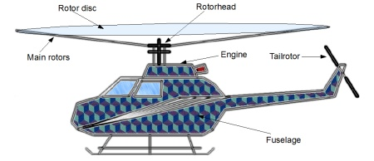

1. **DEVELOPMENTS**

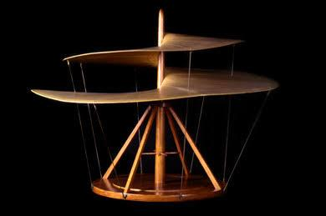

**3.1 Leonardo da Vinci's model-1493**

Leonardo da Vinci's machine for vertical flight, particularly, the 'airscrew' design was created in 1493. It comprised of a stage surmounted by a helical screw driven by a fairly simple framework, much the same as that of elastic controlled model flying machine.

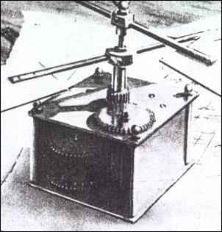

**3.2 Lomonosov “Aerodynamic”-1754**

Lomonosov, the “Father of Russian Science”, a pioneer physicist, chemist, astronomer, geologist, and geographer as well as a researcher in aeronautics proposed the very first self-propelled model of a lifting airscrew. It appears to have been the spring-driven gadget developed and flown. He named his development "Aerodynamic" to be utilized by methods for wings pivoted on a level plane in the contrary headings to depress the air by the organization of a spring of the sort utilized as a part of checks so as to lift the machines into the upper layers of the air.

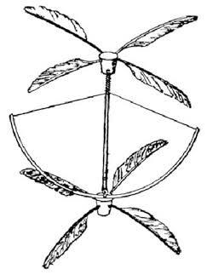

**3.3 Bienvenu & Launoy model-1784**

The essential firm recorded verification of a helicopter being amass dates from 1784, when two French craftsmans, Launoy and Bienvenu, thought up an indigenous toy involving two propellers made of fowls' quills settled to the tips of the pole, around which two strings were bent, tensioning a spring in a crossbow course of action. As it fixed, the spring made the propellers pivot for a couple of moments, adequate to send the toy turning a couple of meters.

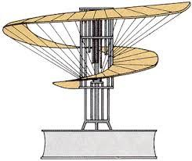

**3.4 Lambertgye model-1818**

Vertical flight vehicle model outlined by Lambertgye in 1818.

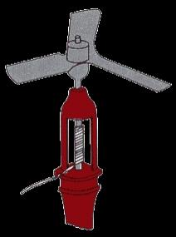

**3.5 Cayley “Aerial Carriage”-1843**

In 1843 Sir George Cayley, the father of British aeronautics, created his "Aerial Carriage" which had four rotors organized co-pivotally in sets. This bizarre vehicle was a change on other contemporary activities, yet Sir George did not prevail with regards to finding an appropriate motor, so the machine stayed on the planning phase.

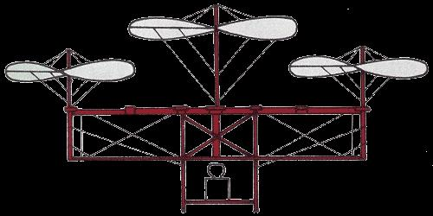

**3.6 Cossus model-1845**

A three-propeller vehicle invented by Cossus. It had three pivoting aeronautical screws that were moved by steam control.

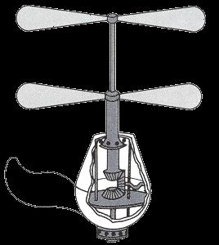

**3.7 Bright model-1861**

It was a little aluminum model by Bright proposed in 1861. It comprised of axles that were suspended underneath an inflatable and pivoted in inverse ways.

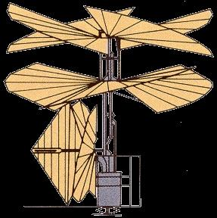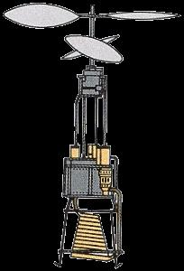

**3.8 Amecourt model-1863**

The French pioneer, Viscomte Gustave de Ponton d'Amecourt, was in charge of the formation of "helicopter". D'Amecourt built a little stream-driven model of his design (still in the French Air Museum) in 1863 and took out French and British licenses on it. Awed with created by the get-together, Jules Verne later made a science fiction novel, disseminated in 1886, that was titled Robur le Conquerant.

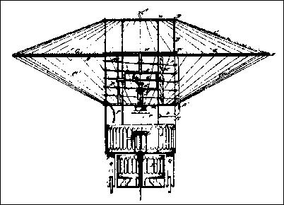

**3.9 Wootton helicopter-1866**

The helicopter was the extent that anybody knows energized with a steam engine which turned no less than two propellers that were settled between the wing and the most elevated gondola. This was a sort of excite ride issue on which the helicopter ought to be pulled to a high point toward one side.

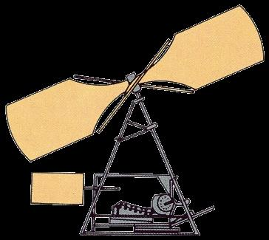

**3.10 Pomes & de la Pauze-1871**

The model delivered by these two French laborers had a "black powder motor", which might be viewed as the precursor of current rocket drive.

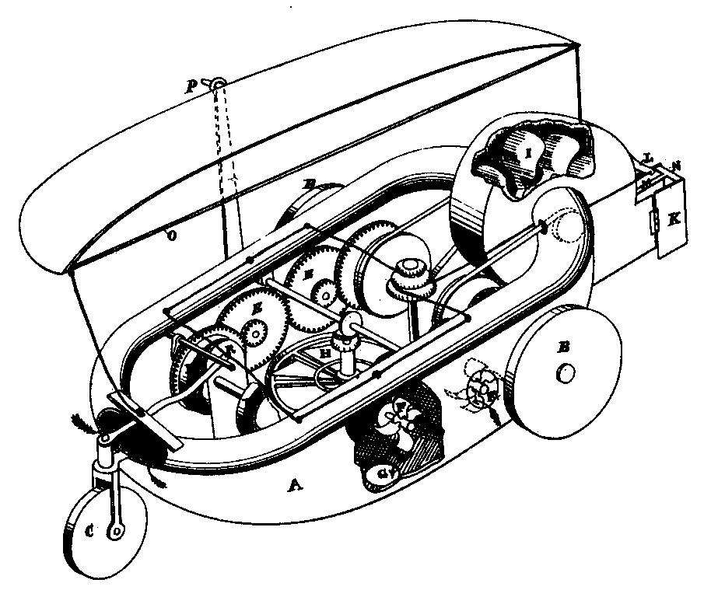

**3.11 Ward helicopter-1876**

John Ward of California who tackled the issue of mechanical trip by methods for helicopter acquired a patent on his invention in 1876. With its assortment of tubes, devices, and turning(spinning) propellers, Ward's flying machine looks like most eagerly a flying pipe organ.

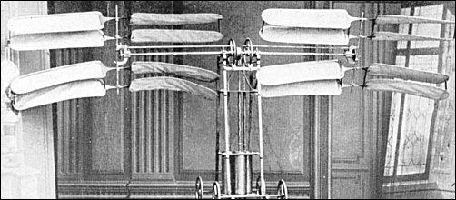**3.12 Castel model-1877**

Castel used a compressed air engine to power two pairs of rotors, each with a diameter of 1.7 meters. The motor, unexpectedly, was bolstered by methods for an adaptable tube from a compacted on the ground. The air ship's aggregate weight was a little more than 22kg.

The device made a successful take-off, but crashes into a wall, which unlucky accident put an end to career.

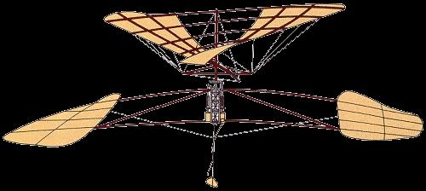

**3.13 Forlanini model-1877**

An Italian professor, Enrico Forlanini, had an indigenous thought for defeating the heaviness of a kettle and its hearth: right away before his analysis began, he constrained steam superheated to a weight of around 10 kilos for each square centimetre into a little metal circle, from which an aligned valve enabled it to escape into the barrels. The total gettogether, including the two rotors, weighed barely in excess of 3.5 kilos. It effectively wind-up airborne, and in 1878 really rose to a tallness of almost 13 meters, where it stayed for around 20 seconds.

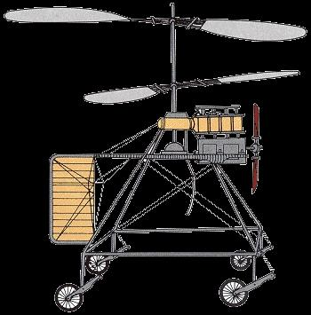

**3.14 Vuitton model-1877**

The second autogyro worked by Vuitton had a little motor which drive a tractor propeller, twin two-sharp edge rotors and a quadricycle undercarriage.

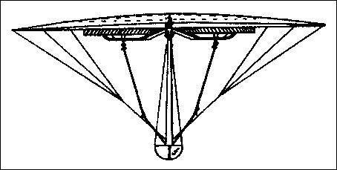

**3.15 Greenough helicopter-1879**

In 1879, John Greenough turned out with an authorized arrangement of calling his machine a trapeze artist, this Syracuse creator designed his helicopter as a huge wing. The Craft's two lifting rotors spun around in two huge roundabout openings cut into the wings. A pontoon formed fuselage was suspended underneath the wing.

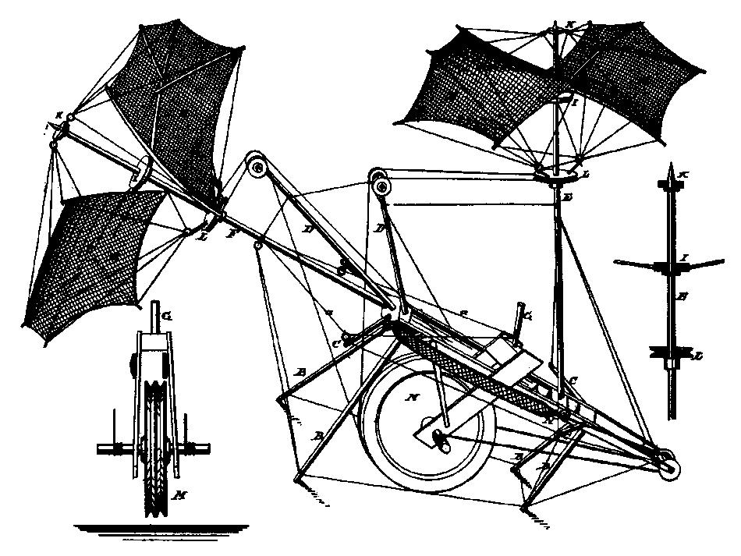

**3.16 Quinby helicopter-1879**

Quinby's helicopter, with its four inflexible legs for an arrival equip, slanted body, and a long nose blast to which were affixed two little sails for a propeller, looked more like an elevated steed than a flying vehicle. The lifting propeller was made of a couple sails, which rotates around a vertical shaft of the machine.

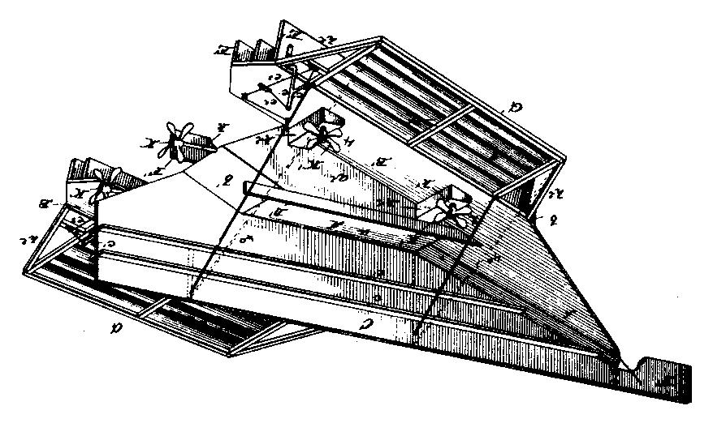

**3.17 Johnston helicopter-1888**

In 1988, Edward Johnston of Alabama, entered the flying field with his thoughts for a functional helicopter including the paper air ship models which school young men make to torment their educators.

Johnson flying machine had six propellers, four for vertical flying and two for giving it directional flight. An intriguing insight about these propellers was the reality they had their own particular individual engines.

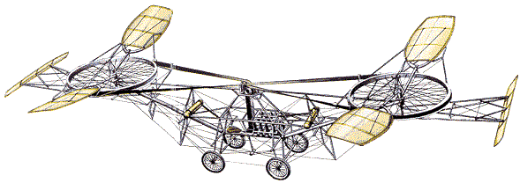

**3.18 Paul Cornu helicopter-1907**

It was the first helicopter to make a free flight, that is, 20 seconds duration with a 24 hp Antoinette engine. It was an open-system structure worked around a bend steel tube that conveyed a rotor at either end, and the motor and pilot in the centre. Power was transmitted to the rotors by a drive belt that connected the two rotors and spun them in inverse ways. Control was to be given by links that could change the pitch of the rotor cutting edges, and by steerable vanes at either end of the machine planned to coordinate the downwash of the rotors.

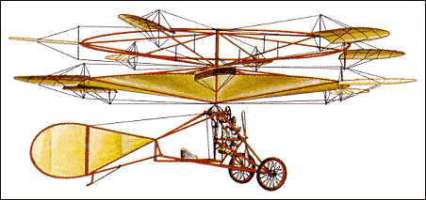

**3.19 Ellehammer helicopter-1912**

Flown in Copenhagen, by the Danish inventor, the helicopter was a twin coaxial with contra-rotating rotors. A similar motor that drove the rotors additionally controlled a propeller mounted tractor-wise to the flying machine's casing. After various indoor tests, the flying machine was exhibited outside and made various free departures.

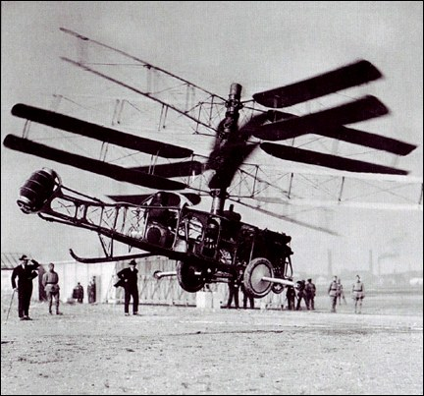

**3.20 Pateras Pescara model-1924**

It was the third largest model built and flown by the Spanish marquis Pescara. It had four co-axial rotors with a 250 hp engine. In September 1923, a 1 km flight endeavor was about finished, before the vehicle slammed. On 24 May 1924 Étienne Oehmichen set a world helicopter record trip of 358m. On 18 April 1924 the model 2F flew 736m at 8 mph to set a record in oversaw vertical flight.

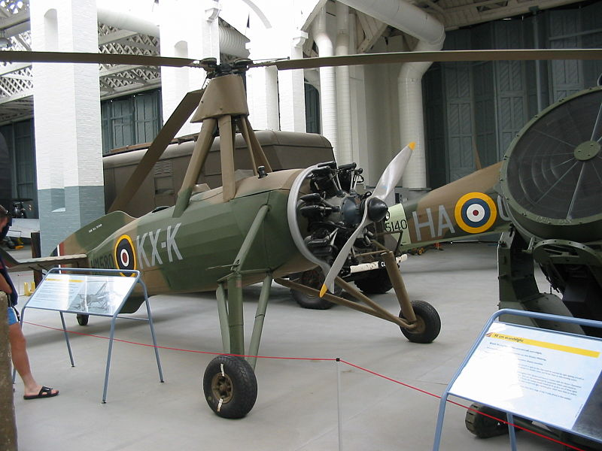

**3.21 Cierva C.30-1934**

It was the best-known autogyro during the second world war. A.V. Roe built more than 100,40 were produced in Germany, more than 100 were built in France by Liord and Olivier, under license from Cierva.

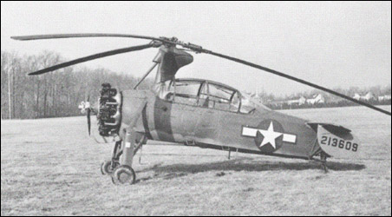

**3.22 Kellett YO60-1942**

The autogyro was used for observation by the US Army. It had an enclosed cabin with a two-crew members seat with a 300 hp radial engine. The rotor framework was diverse with the expansion of the equipment essential for hop departure. The cutting edges were set at "no lift" plot for runup. The rotor was affixed up to 280-290 rpm around 80 or 90 more than the journey rpm.

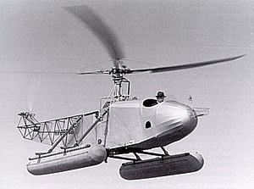

**3.23 Sikorsky VS300 helicopter-1939**

Designed by Sikorsky (father of helicopters), the VS-300, had an open framework fuselage, three blade rotor and a 100 hp Franklin engine. With skims joined, it turned into the principal down to earth land and/or water capable helicopter.

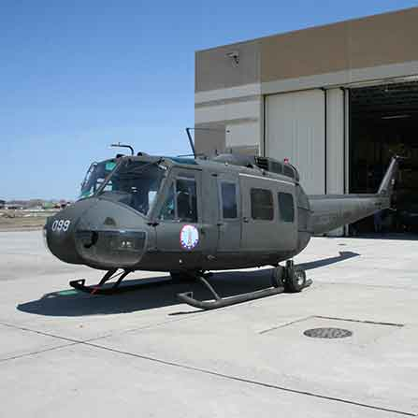

**3.24 Bell UH-1H (The “Huey”)-1956**

UH-1H also known mas “Huey”, contributed a great towards the Vietnam as well as the Korean war. It got an engine of 1400 hp with a total of 5432 built under license in Taiwan by AIDC.

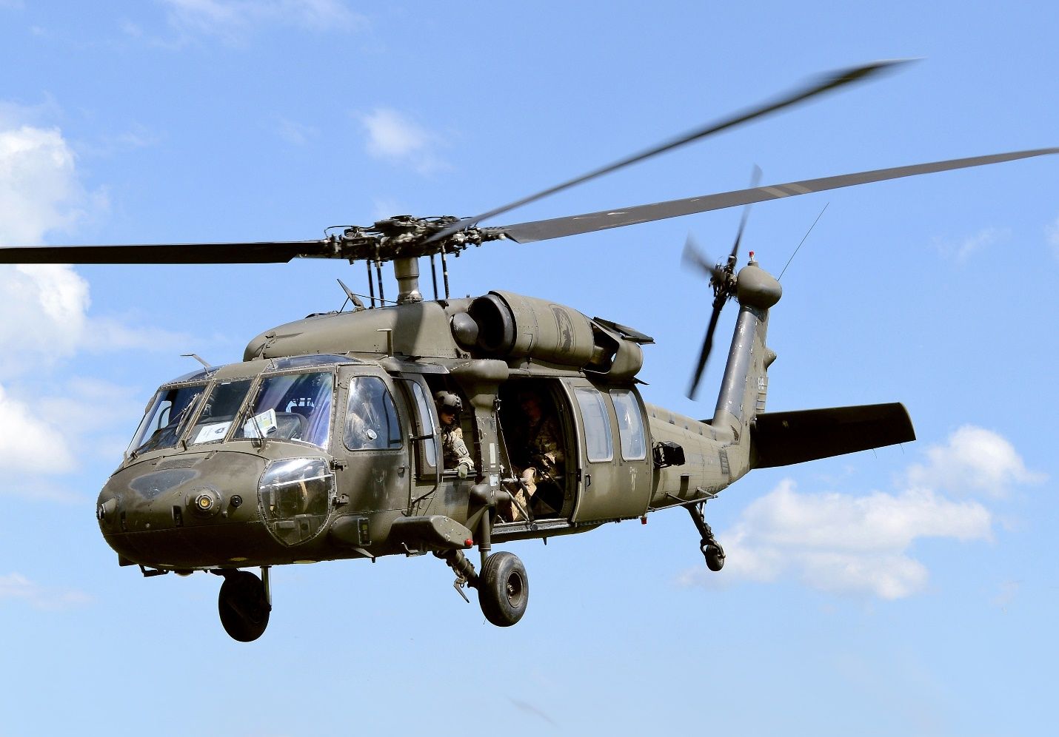

**3.25 Sikorsky “Black Hawk”-1976**

The helicopter got a unique flattened appearance about its transport hold, it got a number of interesting and safety features, including two engines which can keep the aircraft aloft on its own, redundant subsystems, a crash-proof cabin and a well-made landing gear. Today, the Black Hawk is one of the most popular helicopters in the US military with more than 2500 in use.

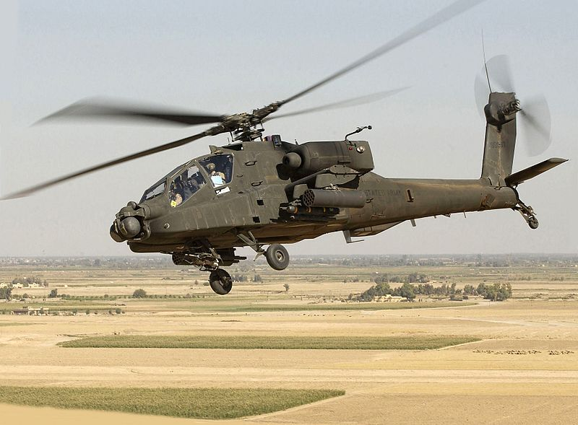

**3.26 Hughes “Apache”-1982**

This gunship helicopter was basically made for the Vietnam war and to destroy Soviet tanks. During the 1991 Persian Gulf War, the helicopter performed well both as a tank and an assault vehicle. It generally had an engine of 1700 hp (shaft horsepower) with a range of 800-1200m.

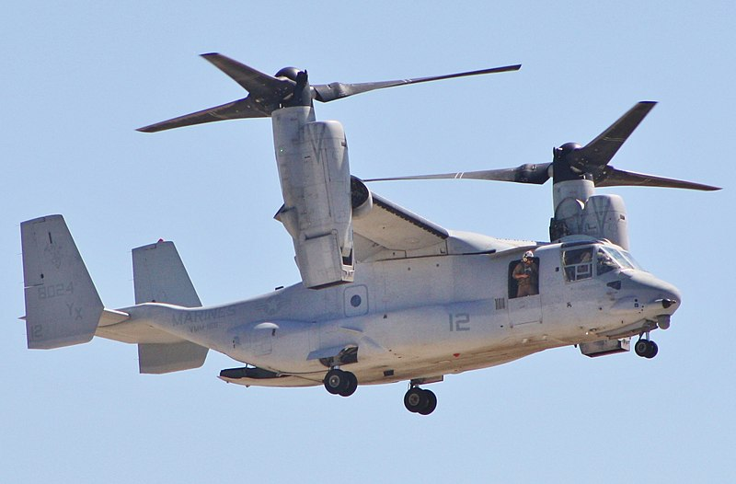

**3.27 Bell Boeing V-22 “Osprey” Tiltrotor Craft-1989**

It was a result of the US military services for a hybrid helicopter which could carry more and move faster than a normal helicopter. It is intended to consolidate the usefulness of a traditional helicopter with the long-go, rapid journey execution of a turboprop airplane.

1. **FUTURE DEVELOPMENTS**
   1. **Single Engine Operative Mode**

Single motor agent (SEO) mode which enables a twin motor helicopter to close down one of its motors while in voyage to spare fuel, and restart it again quickly when required. Airbus Helicopter displayed the ecological Clean Sky 2 demonstrator to demonstrate that new innovation could make helicopters all the more naturally inviting by decreasing commotion and discharges. Key highlights:

* SEO – Single engine operative mode allows a dual-engine helicopter to shut down one of its engines while not in use, to save energy(fuel), and to throttle or lift rapidly.
* Supercritical transmissions including less parts, which will make the framework lighter and diminish upkeep cycles.
* Supplementing flight-by-wire with mechanical flight control, including savvy capacities, for example, auto trimming.

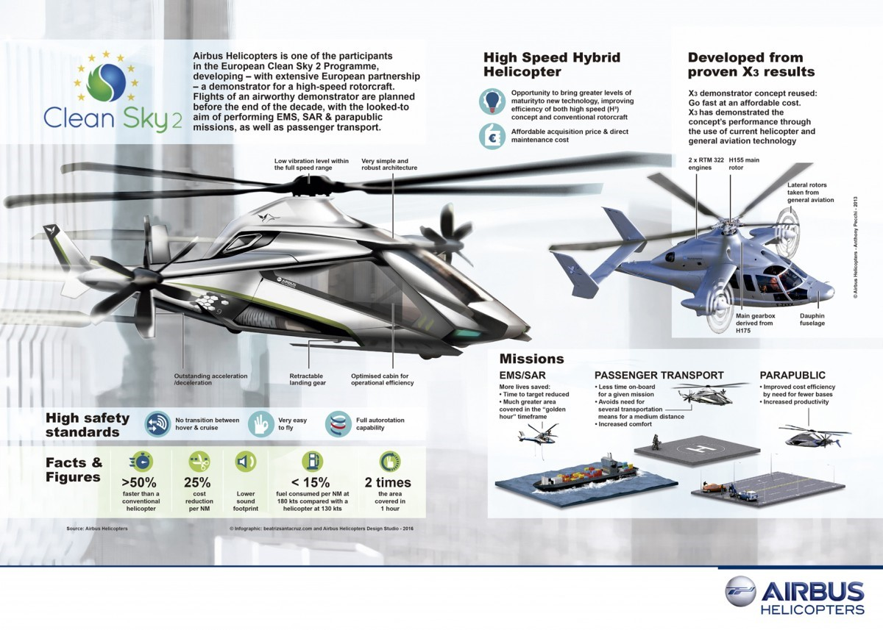

## 4.2 Untraditional tail rotor without horizontal stabilizers

**Bell Helicopter** has unveiled a range of future-generation helicopters with some extraordinary features.

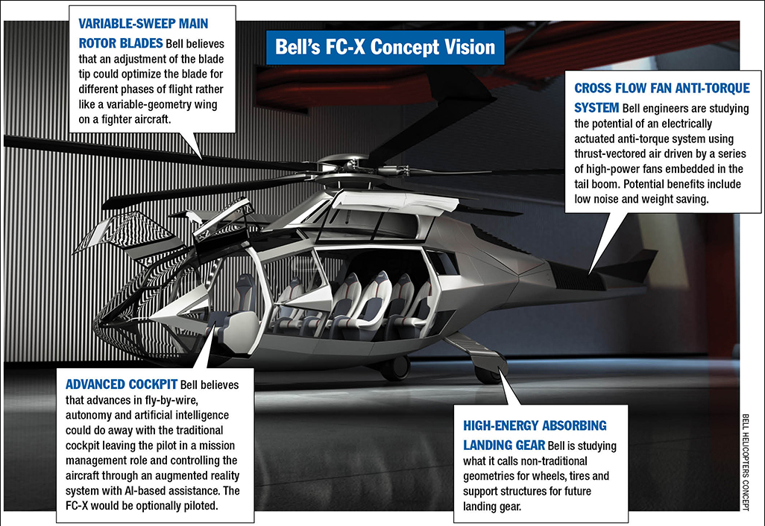

•Fly-by-wire and self-governing abilities consider single seat pilot.

•Electric mixture framework in the tail rotor for a half and half against torque framework. Different fans and a remittance for a venting framework on the two sides of the tail, so it can push in either course.

•No flat surfaces.

•Hybridized impetus. This consolidates propelled warm motor centers for the fundamental impetus with electric dissemination and engines to drive the framework for additionally control and simple vehicle activities and support.

•Various landing gear designs are being considered.

## 4.3 Civil Tilt Rotor Concept

**Observing the development of Agusta Westland AW609, Leonardo Helicopters has futuristic plans to test the prototype of a next-gen tiltrotor by 2023.**There were a couple of new advances revealed including:

• New rotor cutting edges, wings and ailerons that will initially be tried utilizing subscale articles on an AW609 testbed

• Plans to supplant the full motor tilting of the AW609 by essentially tilting the gearbox and rotor edges

• Fly-by-wire frameworks for cutting edge flight controls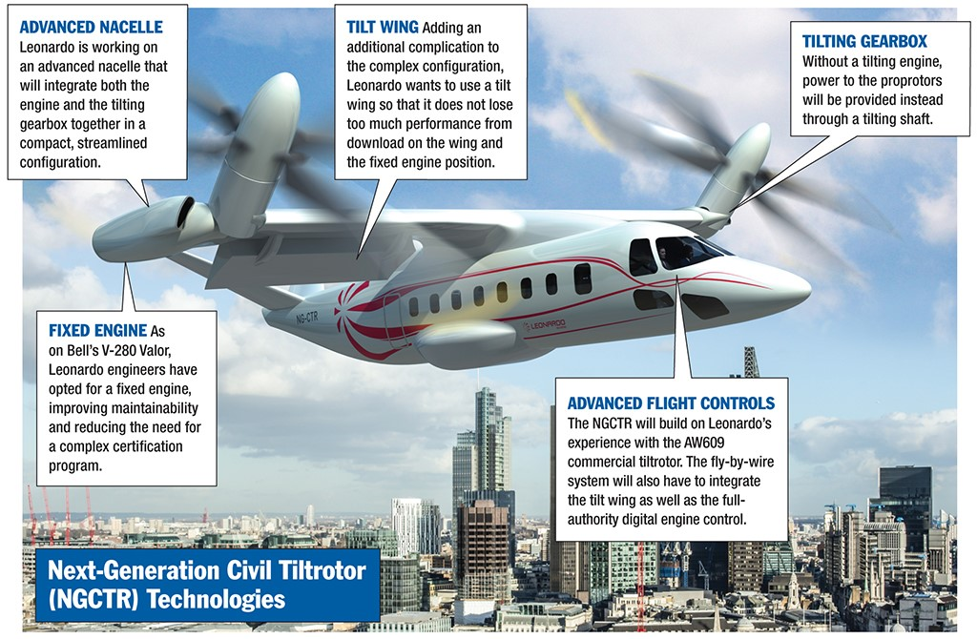

Leonardo's specialists have propelled a long-haul program to build up an electric-fuel tail-rotor. Timing for qualifying a creation adaptation hasn't been affirmed yet.

1. **REFERENCES**

***Michael Heatley-The Illustrated History of Helicopters-Exeter Books (1986)***

***John M. Seddon-Basic Helicopter Aerodynamics-Blackwell Science Ltd (1990)***

***Giorgio Apostolo-The Illustrated Encyclopedia of Helicopters-Bonanza Books (1984)***

***A.R.S. Bramwell, George Taylor Sutton Done, David Balmford-Bramwell’s Helicopter Dynamics-Butterworth-Heinemann (2001)***

***en.wikipedia.org/***

***images.google.com/***